SIRM Unit Tests

Contents

Introduction 3

Summary of Tests Conducted 3

Procedure of Tests 4

Reduce Parent Efficiency 4

Efficiency Percentages High vs Low 6

Remediation Factor 7

Repair Factors 9

Stoichiometric Factor 10

Backup Percentages 11

Outages 12

Appendix 13

# Introduction

The Stochastic Infrastructure Remediation Model (SIRM) tool allows for a series of interconnected infrastructure sectors to be modeled and considers the realistic variability of the impact of a CBRN event (CBRN stands for chemical, biological, radiological, and nuclear). The SIRM tool has two components an ArcGis portion where there is an input of an area of interest and then a Python GUI tool is called, which will model the rate of recovery of the area.

The focus of the tests was on the Python GUI portion, where several key functionalities of the tool where tested, which are Parent Reduction, Efficiencies, Remediation Factors, Stoichiometric Factors, Backup Percentages, and Additional Outages. Each test will be reviewed in detail, and results of the tests will be recorded.

# Summary of Tests Conducted

Table Summary of Tests



In Table 1 there is a summary of the expectations of the tests and results of the tests that where conducted, 7 tests were conducted and all passed, an example of how the code tests looks can be seen in the Appendix. All tests were done comparing the recovery times of the two scenarios.

# Procedure of Tests

All tests that have been conducted where comparing the recovery days, which were calculated by the python tool. The procedure of the tests was as follows values were chosen as baseline parameters to be compared to an increase or decrease in the value. If a feature was to be tested, arbitrary baseline parameters were chosen, or the feature was toggled on or off. Then, the python GUI tool was run, and a Comma Separated value file or .csv file is outputted and saved for the test to be used in the python script to test the values. An example of the output of the python GUI tool is shown in Figure 1. 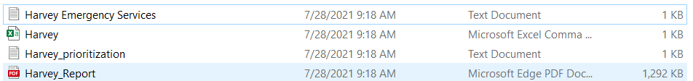

Figure Example of GUI tool output

The Python Script was written with the module unit test to help automate the unit testing. This module will tell the user if the proper result is achieved either asserting a pass or fail. A true or false value was assigned to see if values where larger or smaller, then each other and finally the test results were given.

# Reduce Parent Efficiency

The first test conducted was on the Reduce Parent Efficiency functionality. This simulates some sectors using supplies from other sectors that are dependent on each other. An expected result when Reducing Parent Efficiency is that the days of recovery should be higher when reducing Parent Efficiency. This is because when you take supplies from the dependent sectors, it will take longer to recover. A screenshot of the scenario used is shown below.

Figure Example GUI 50% (Parent Reduction off)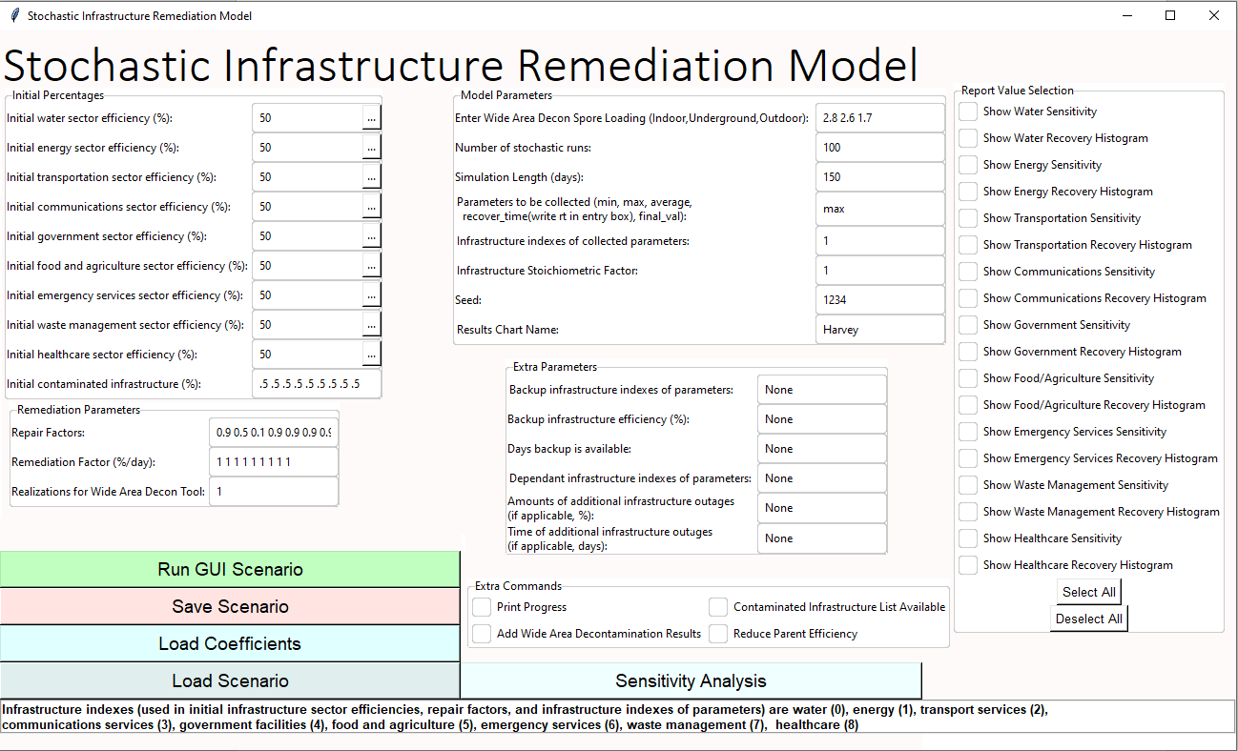

The scenario was run with and without the parent efficiency and the days of recovery are shown in the tables below.

Table Parent Reduction On, Recovery Times in Days



Table Parent Reduction Off, Recovery Times in Days



As shown in the charts, changing the Parent Reduction will, in fact, change lengthen the recovery time. The unit test module confirmed a passed test that with parent reduction on the recovery time is larger.

# Efficiency Percentages High vs Low

The next test that was run was the initial percentages were changed. The Initial Sector Efficiency represents the operating efficiency of the sector. The results of the two runs are shown in tables 4 and 5, comparing the recovery times.

Table 80% Efficiency Days of Recovery, Recovery Times in Days



Table 50% Efficiency Days of Recovery, Recovery Times in Days



The unit test module confirmed that increasing the Efficiency will decrease the recovery time. The unit test module gave the test as passed.

# Remediation Factor

The remediation factor is defined as the linear percentage per day by which contamination is reduced. The results that would be expected are that the lower the remediation factor is, the higher the days of recovery would be this is because less contaminant is reduced per day. Conversely, a higher remediation factor would produce smaller days of recovery. The same 50% efficiency was used as the baseline for both tests and the remediation factor was the only thing that was changed. The remediation factor was lowered to .01%/day for each and then changed to 1%/day.

Table Recovery Times in Days



Table Recovery Times in Days



Comparing the results from Tables 6 and 7, the remediation factor when decreased to .01% per day is shown to increase the days of recovery compared to the Table 7. The Unit Test written had given a passed result.

# Repair Factors

Repair factors are defined at the rate of at which society works to restore the infrastructure services. It is reasonable to speculate that the higher the repair factor the lower the reparation days. The repair factor was run at .1 and then sent to .9 with all the other inputs as figure 2.

Table Higher Repair Factor Recovery Times in Days



Table Lower Repair Factor Recovery Times in Days



Due to the Unit Test module giving a passed test and by inspection it can be concluded that the repair factor functionality is working properly, and the test was passed.

# Stoichiometric Factor

The stoichiometric factor is the value by which each stoichiometric coefficient in the reaction equations is multiplied by. This varies the level of stochastic behavior, as well as the stability of the data. With higher stoichiometric factors the days of recovery decrease due to the behavior of the reactions. The tests were conducted with figure 2 inputs while changing the stoichiometric factor from 1 to 400.

Table Stoichiometric Factor of 1, Recovery Times in Days



Table Stoichiometric Factor of 400, Recovery Times in Days



The stoichiometric factor variation produced the expected results and the unit test module confirmed what figures 10 and 11 show that when varying the stoichiometric factor, the days of recovery decrease. The days of recovery decreased and thus the unit test module give a passed test.

# Backup Percentages

In the table below there is a description of the backup percentages inputs that need to be entered simultaneously.

Table 12 Description of Backup Percentages



When testing the percentages, the days of recovery for the chosen infrastructures should go down slightly. The decrease should be related to the reported connection that the two infrastructures have. In the test case, the Backup Infrastructure index was 1, (energy), and the dependent infrastructures was 6, (emergency medical services). In the test a decrease was seen in the days of recovery in the emergency medical services indicating a passed test.

# Outages

The additional outages are percentages and days of additional outages seen during the event. The percentage is the efficiency of the outage, and the days are how many days are in the outage. When testing the additional outages functionality, the user expects larger days of recovery as compared to no outages.

Table 13 No Additional Outages



Table 14 Additional Outages



The Additional Outages variation produced a result and the unit test modal confirmed what Tables 13 and 14 shows with no additional outages having smaller recovery time indicating a passed test.